Repertoire: A chocolate-prune cake that masquerades as a loaf

By Jessica Battilana March 13, 2020

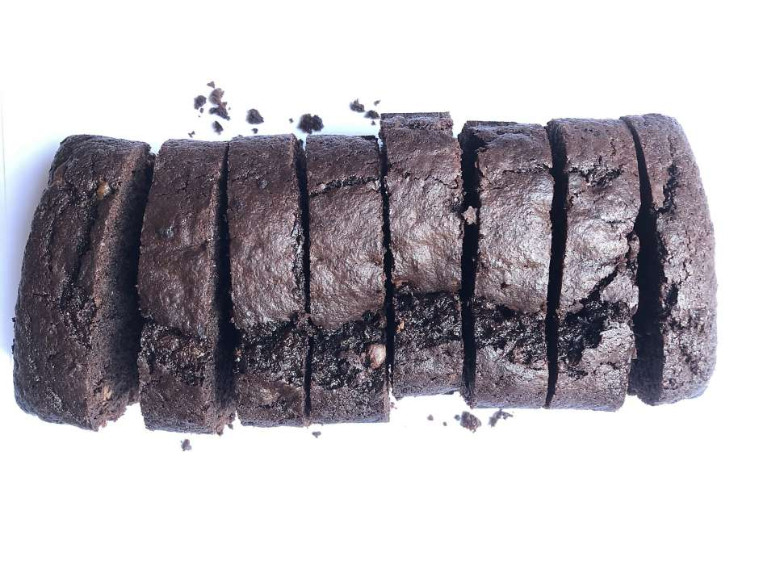

While fine-tuning this week’s recipe for chocolate-prune cake, I ended up making many loaves of it. Every time someone came over, I gave them a slice to eat out of hand or one to take home. Even the imperfect first attempts, foals standing on wobbly legs, were very good. As it happens, everyone loves cake and is glad to be offered some.

I somewhat deceptively called it “chocolate bread,” since it’s baked, like banana bread, in a loaf pan. But just so we’re clear, there’s nothing bread-like about it. It is cake in cake’s clothing, nearly black in color thanks to a generous amount of good cocoa powder and melted chocolate, with a tender crumb, studded here and there with depth charges of chopped chocolate and — surprise! — bits of prune. The prunes add moisture but also sticky bits of sweetness you encounter every few bites, a very nice feature if I do say so myself.

I created this recipe for those who think cake-making is fussy, who do not own a stand mixer and do not want to mess with layers or frosting, but who still would like cake from time to time. You mix this batter by hand in a big bowl, and because it’s made with oil instead of butter, there is no creaming to be done, no beating necessary.

It’s a dump-and-stir situation, but you’d never know by tasting that it was a cinch to make. It’s the kind of thing you can throw together in a spare half-hour, the sort of cake that wins people over, which is how I finally settled on its name. If you’re able to hold out, I think it actually tastes best on day 2; tightly wrapped, it’ll keep for many days at room temperature, provided it lasts that long.

*Jessica Battilana is a San Francisco freelance writer and the author of “Repertoire: All the Recipes You Need.”*

“Hearts and Minds” Chocolate-Prune Cake

Makes one loaf; serves 8

Unsalted butter, for greasing the pan

**½** cup good-quality Dutch-process cocoa powder, such as Guittard, plus more for dusting the pan

**5** ounces milk or semisweet chocolate, finely chopped

**15** dried pitted prunes

**10** tablespoons buttermilk

**½** cup canola oil

**½** cup sugar

**½** cup light brown sugar

**2** large eggs

**1** teaspoon vanilla extract

**1** cup all-purpose flour

**1** teaspoon baking powder

**½** teaspoon kosher salt

**¼** teaspoon baking soda

**Instructions:** Preheat the oven to 350 degrees and arrange a rack in the center. Grease an 8½-by-4½-inch loaf pan with butter and dust with cocoa powder.

In a small saucepan, add about an inch of water and bring to a simmer. Put half of the chopped chocolate in a small heatproof bowl and set the bowl over the simmering water, making sure the bottom of the bowl does not touch the water. Let stand until the chocolate has melted, then stir until smooth. Keep warm. Put the prunes in a bowl and pour simmering water from the saucepan over the prunes to cover; let stand 10 minutes.

In a large bowl whisk together the buttermilk, canola oil, sugars, eggs and vanilla. In a separate medium bowl, sift together the flour, cocoa powder, baking powder, salt and baking soda.

Remove the prunes from the water and finely chop. Stir the dry ingredients into the wet, mixing until smooth, then stir in the melted chocolate. Add the remaining chopped chocolate and the prunes and stir to combine. Transfer the batter to the prepared pan and bake on a rack in the center of the oven until puffed and cracked on top and a toothpick inserted in the center comes out with a few moist crumbs clinging to it, about 40 to 45 minutes.

Let cool on a wire rack, then turn out of the pan and let cool completely. Cut into fat slices and serve.

[https://www.sfchronicle.com/recipes/article/Repertoire-A-chocolate-prune-cake-that-15127853.php#](https://www.sfchronicle.com/recipes/article/Repertoire-A-chocolate-prune-cake-that-15127853.php)